what’s going on in…
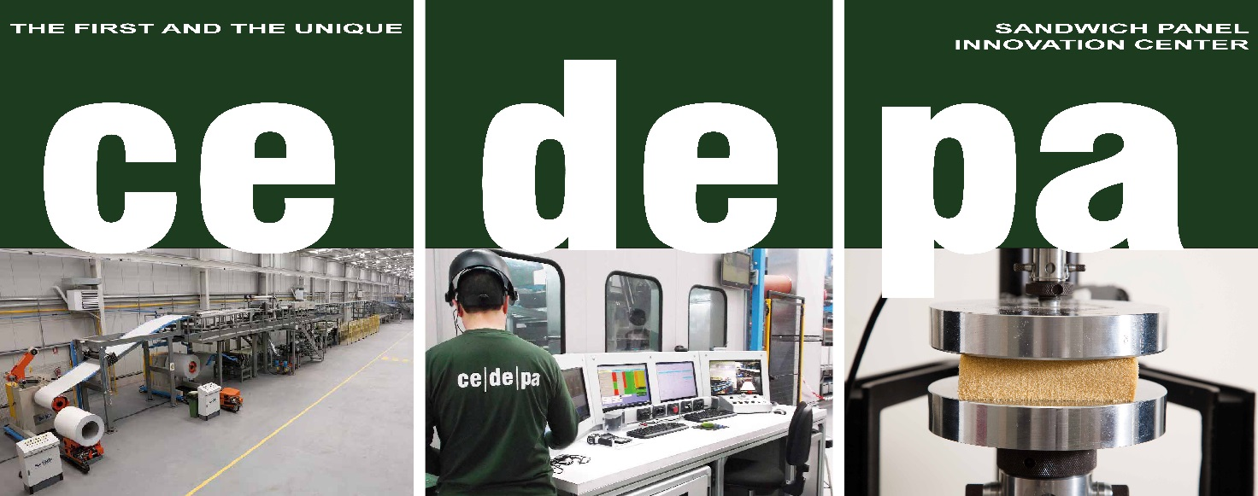

DOW’s V PLUS PERFORM™ ALLIANCE PROGRAM
GAINS MOMENTUM WITH CEDEPA

Along with the strong collaboration of CEDEPA, innovation partner, an all-round assessment and testing of new technologies can be carried out.

The V PLUS Perform™ (VPP) Alliance Program was introduced in 2017 to key customers down the value chain. By bringing together expertise from panel manufacturers, architect networks, sustainable building certification bodies and independent R&D and testing facilities, it becomes possible to build downstream brand awareness.

Along with the strong collaboration of CEDEPA, innovation partner, an all-round assessment and testing of new technologies can be carried out. CEDEPA is a valuable platform for the industry and creates an ideal situation for our current and new customers, because it brings a real-life experience to the process. The facility inaugurated back in 2011 has now been upgraded to include Internet of Things (IOT) telemetry and advanced manufacturing 4.0 capabilities.

As of February 2020, the V PLUS PERFORM ™ Program has been launched with two customers – Hiansa in Spain and Terasteel in Romania supported by superior insulation technology, robust demand generation and content marketing initiatives.

According to José Ramón Piqué – Managing Director, Hiansa , "Innovation and Sustainability are two concepts from Hiansa Panel, we believe, are closely linked. Dow's V PLUS PERFORM ™ technology together with its team have allowed us to develop our ULTRA panel in order to respond to the needs of an increasingly aware society in terms of environmental commitment and sustainability. "

